

**CAB432 Cloud Computing**

**Assignment 1**

**Title: Property Map**

**Name: Month Yean Koh**

**Student ID: N9070095**

Table of Contents

Introduction 3

Services and Data APIs 3

Mashup User Cases and Services 4

Use Case 1 Getting Start with the map 4

Use Case 2 Autocompleting the location Name 5

Use Case 3 Show House Information Location 6

Use Case 4 Search Nearby Places By House Location 7

Client side 8

Server side 9

Dockers Configuration 9

Testing and limitations 10

Testing 10

Test 1: Undefined Current Location 10

Test 2 Undefined Search Location Input 10

Test 3 Different Combination Tags 11

Test 4 Preset Combination Tag 12

Test 5 Self Upload Photo To The Map 13

Test 6 Invalid Title Of The Photo as House Address 14

Limitation 15

Possible Extension 16

Appendix 17

User Guild 17

DockerFile 18

# Introduction

House Tenants Searching System API provide user with the list houses that are currently available for rent and looking for tenants. It will list out all the house location on the map with the house information and a gallery of that house. Then user able to discover the nearby houses which available to rent. However user also able to search thought with specify location via search engine.

The users will be tenants who are looking for rental homes. They will be able to find nearby places available to rent by inputting address, suburb, postcodes or region name into the search engine of google map, and google map will go to that area and it may show up the house available for rent if there is any houses data available.

Google Place will return results and list nearby houses that are looking for tenants with the drop pin icon in the Google Map. A simple description and pictures of the house will also be displayed along with the house's address. The user will be able to browse around the map and look for other houses around the area.

Furthermore the user will be able to click on the house for more details. It will pop up the detailed information of the house with a gallery of pictures, and also the actual location of the house on the map, the number of rooms, bathrooms and toilets in that house. It will also display the distance to the closest bus stop, shopping Centre, restaurant and the distance and time taken to university by bus.

# Services and Data APIs

* Flickr API – User able to upload house photo that looking for rent out with specify tag and House Address as Flickr Title to Flickr server. Furthermore The Specify House information might show up in the google map when google map run.
* Google Map - When Google Map Load, It might Load up the Flickr Database and search with Specify Tag and Return the result with the photo keyword as the address and make it as a marker and put in into google map AS a google Place Marker.
* Google Place - When Google Map run Google Place will retrieve the data that from Flickr and process looking for specify address and place the marker on the exactly location on google map.
* Foursquare – When user click on the marker on the google map, Google Place will return the Marker of Store nearby that House Area. Furthermore the marker of Nearby Store Will also show up the information of the Store and also some random that been taken at that place and retrieve from Foursquare Database.

# Mashup User Cases and Services

## Use Case 1 Getting Start with the map

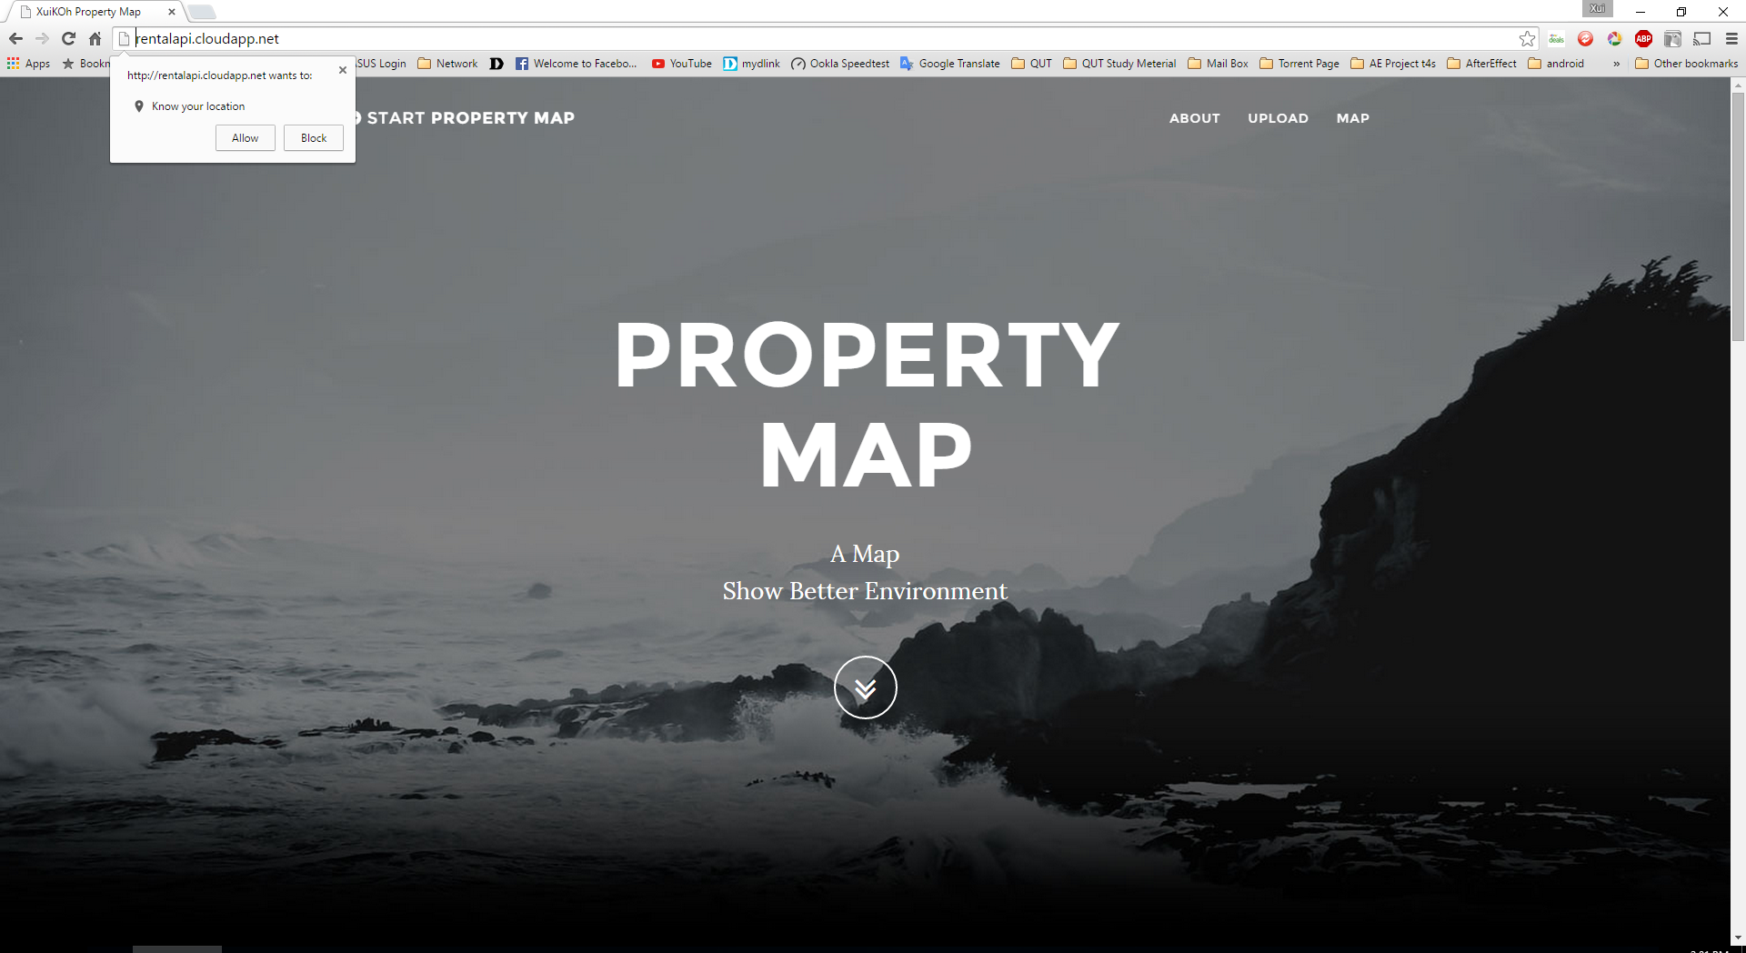

When The Web Page Loaded Google Location API Extension will be loaded and asking for permission to get know you current location by using HTML5 geolocations service.

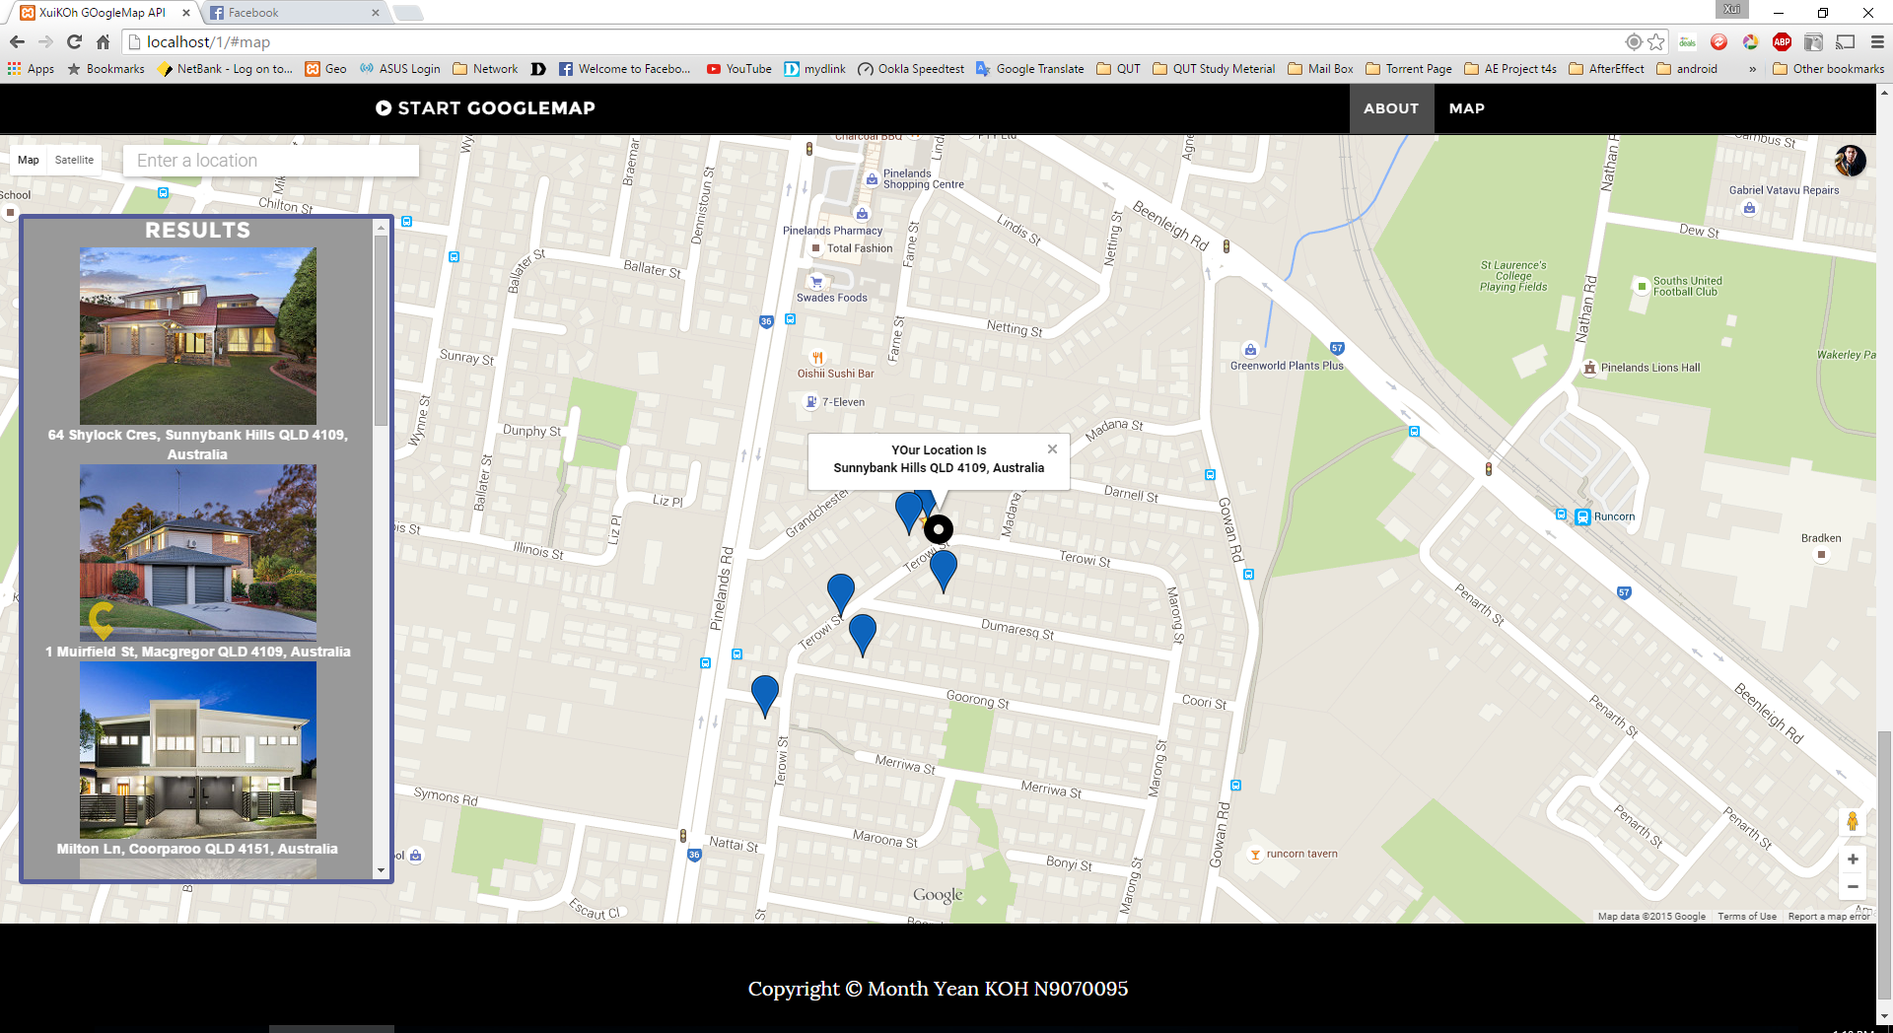

Therefore Google Map will prompt and show up your current location along with the simple location address with a black marker and stated on the map once you allow the Extension to access your location.

After the Google Map been load up, The Flickr API will search up the houses And return the list of the result with the matches of Combination Tags and Keyword on the left Panel on the map, and the Result of the place will be placing up with a Blue Marker in around the google Map.

## Use Case 2 Autocompleting the location Name

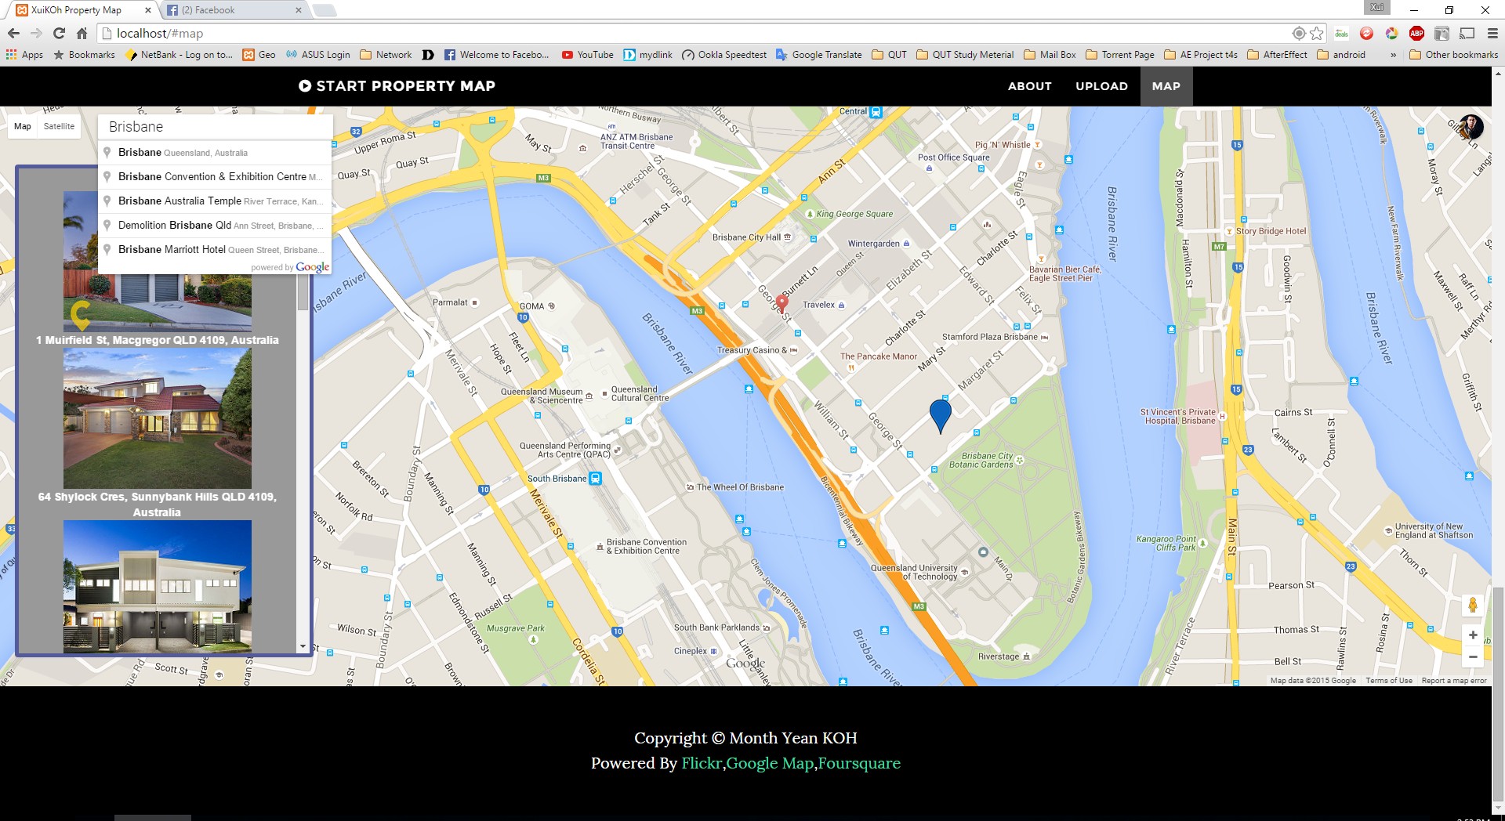

User able to browse and play around the map or Search For the specify location and get know what’s nearby at your current location. Or even search for the place through the search box that appeal on the top left corner and look for your place see whether a blue marker are stated on your nearby

At the mean time User Able to Click on the House Photo that stated on the left panel of the map, or the blue marker on the map, and the map will quickly be zoomed center to that particular house location and show out the information of the house in a small info window.

## Use Case 3 Show House Information Location

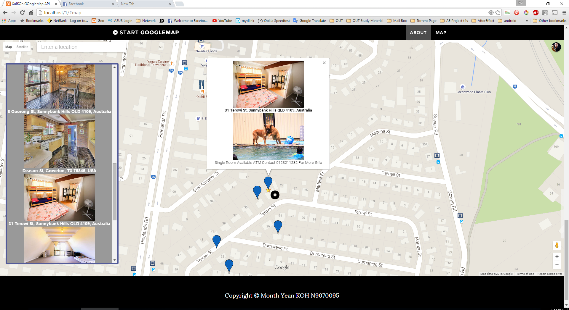

The Blue Marker will result the information of that Places with the Photo and the house address come on the next line. Beside, info window might able load and show up the house description and other photo that related with the house. if there is any of the house photo available, the others house photo will showing up together with the main house photo and well as the description.

If User interested on the House or want to get more details about the house Feel free contact the person with the phone number that listing on the description or click on the photo and will direct you to the particular Flickr Post of that house and get contact to the house owner.

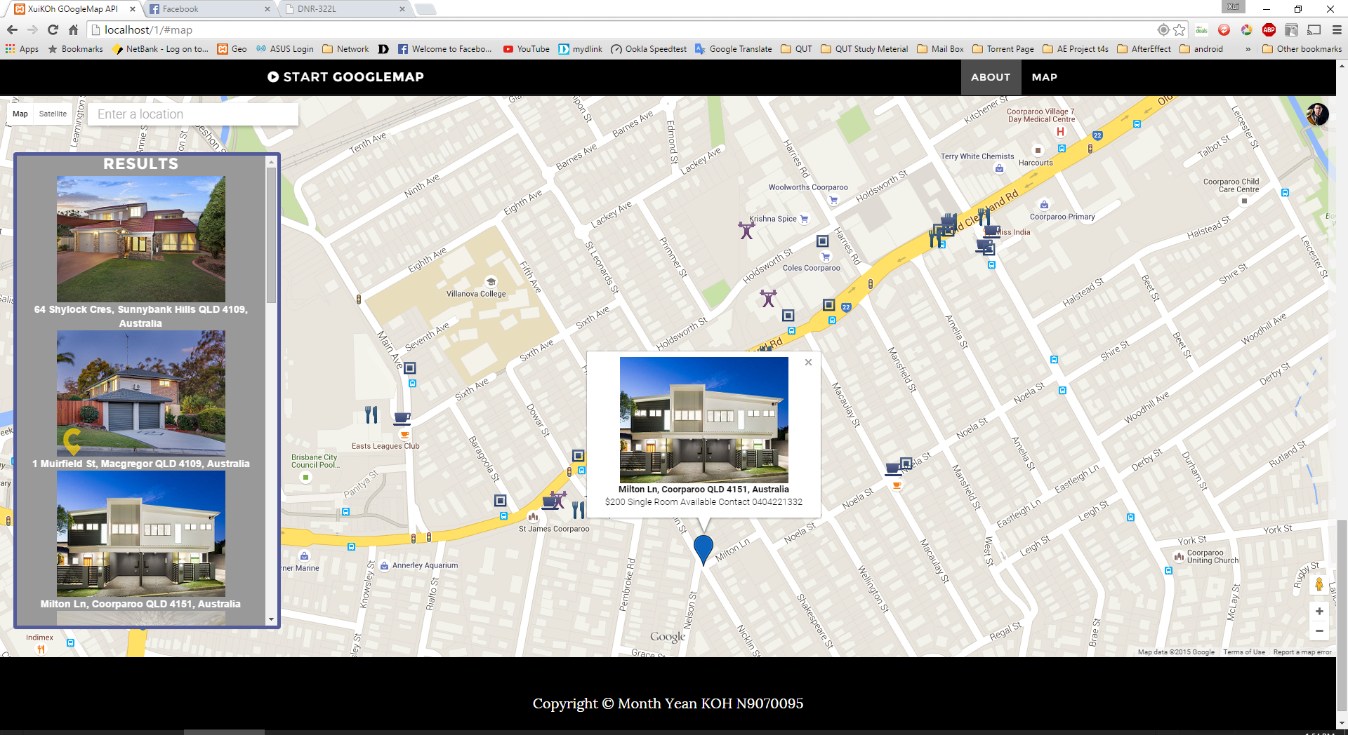

## Use Case 4 Search Nearby Places By House Location

At the mean time beside the house info been show out on the google map with the small info windows, there is also a quick search with the nearby places with (food store, shopping mall, gym or even bus station) around that area, and place up the marker on the google map with following of the categories of icon. So that user might know what is on the nearby and able to count for the distance between the places and the house.

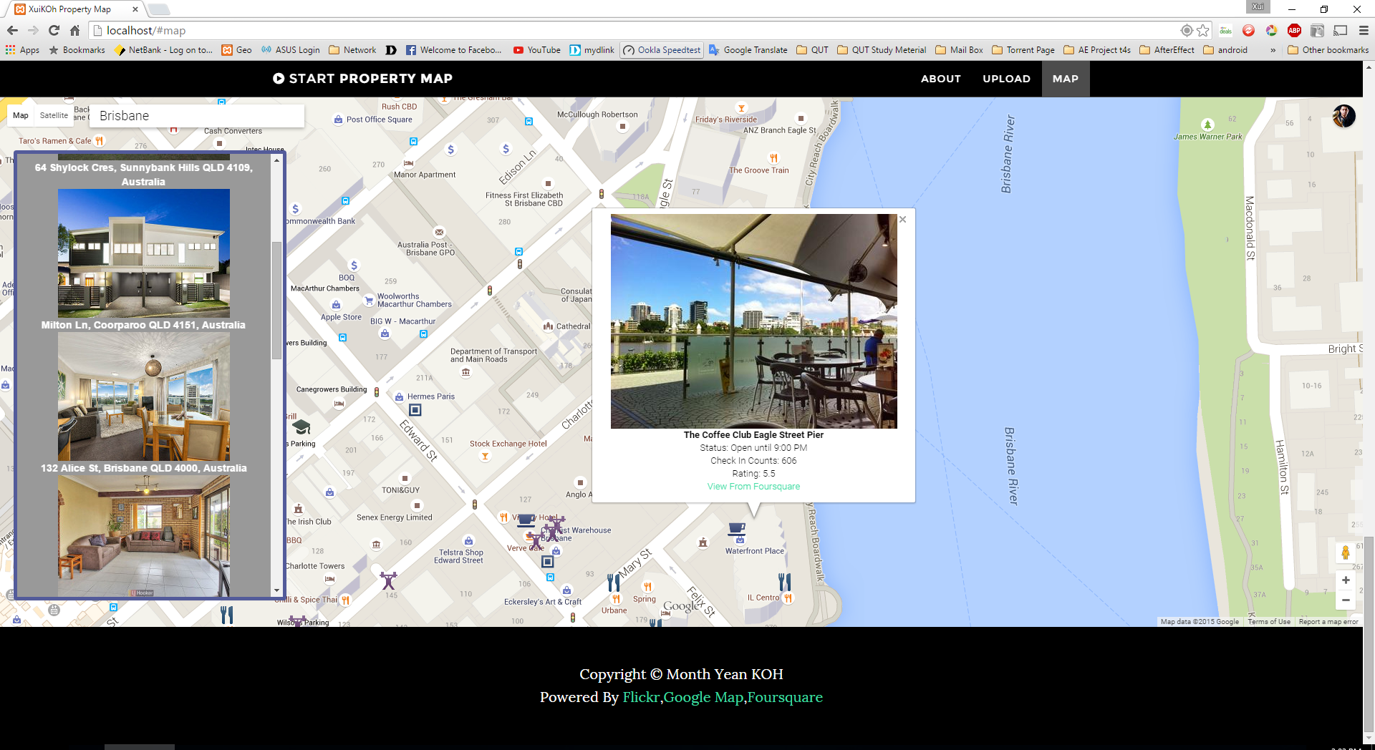

Furthermore when you click on the Place, It might also show up an info window with the photo that been taken recently on the place. As well as some information regarding to that place likes the status about the store right now, check in counts, and rating of that place if the data available. Therefore you able to click on the link for view more details information of that place directly from Foursquare Web API. . If the data is not available from foursquare the info window will only show the place name or foursquare photo. Technical description of the application

## Client side

As on The Client Side it use up the web technology with HTML as the markup language and twitter bootstrap been used as the web page layout. And JavaScript were the Main Scripting language used to programmed on this Mashup API

When Web page begin load it will first load up the Google Map API On the web page, after the web page been fully loaded. It may execute the Flickr Photo Searching function by sending photo searching request to the server side, Therefore Server Side Will load up Flickr API and search up some Flickr Photo Data base with the Specify Tags Combination, once found the result it store the result and past to client side.

In This Project It using The Combination Tag with “House & Rent & Brisbane” It Search through Flickr Database which the photos have the specify Tags and Retrieve The Flickr Photo Data array as JSON Format and passing the Flickr JSON Data Sources To Google Place API.

Google Place API will process the JSON Data Sources that return from Flickr API and used up those Flickr Photos which have contain House address as the Flickr photo Title to search and find for the matches on google map between the google map address and photo title.

Once Google Place found the matches between house address and the street name on google map. It will Place a Marker with the specify house Location in Google Map. And store some relevant Information of the House in the Marker.

Furthermore when the Result house Marker on the google map been click. Google Place will execute nearby places searching with the location of that marker and search for the specify type of place like bus station , gym , food store, shopping mall and place the result as a marker on the google Map.

At the same time when the marker been click. Another Flickr API Function will be call and send a request to the server and look for other photos that regarding to that house. The client will pass the house address as keyword as well as the additional Combination of Tags with Brisbane & House & Rent & Floor plan. If there is any floor plan photo available, it might be showing up in the info windows together with the house photo and house address and with the house Description Information once the House marker been click.

Beside it also able to search for the nearby place and location by input the place name or location at the search box and it might result the place location or result the type of the place.

At Last when It Click on the Place Marker, Foursquare API Will executed and search for the relevant information of that Place in foursquare and retrieve the foursquare data and showing up the Foursquare Information on Google Place marker.

## Server side

Node.js are used as the web server on the server side as event based and it able to handle incoming request while another operation are still taking in place , furthermore express.js also been used as web application framework of node.js and deploy on this Mashup API. Therefore Flickr And Foursquare API will be call and use In the Server side.

Furthermore most of the API Sent And request process are done in the server side. By using java script to program and deploy the server script. It used to store all the API function, beside it also use to store all the secret credentials information as well as the API key data that use to access through the API. As well as the following Combination tags of Flickr that use to search for the Photo on Flickr API have also pre-set on the server. And keep the data inaccessible from client side.

So once server side get request from the client side with the parameter, server side will paras the parameter that sent from the client side and get use with the parameter and sent a request to the API server. Therefore the server side will get back the respond from API server with the data , Furthermore once server side get the respond from API server, it will paras and process the data and make it to JSON format and sent back to the client as a respond.

So that, in the client server it will used up the JSON data and process and convert the data and return the information back to the end user such as Word and images.

Beside there server side have set up only load up some particular files folder and end it might not able to easily to get access other unnecessary files or folders that it made the entire API become more safety, secret and avoid unauthorized access changes because of information leak while the application deploy

# Dockers Configuration

A Docker Image had built and deployed on to the Microsoft Azure Cloud Server with the link of <http://rentalapi.cloudapp.net> with that Docker image it has contain the Property Map API Mashup web page as well as the web server. And expose on the port connection of 3000. Beside Docker Run the Image and map the public port from 80 to pirate port 3000. Furthermore the Docker Also been push to the Docker hub and been pull to the Microsoft Azure Cloud Virtual machine and rebinding the public port with 80 to the Docker container with private port 3000. Then the web site are up and good to access with the link of <http://rentalapi.cloudapp.net>.

# Testing and limitations

## Testing

### Test 1: Undefined Current Location

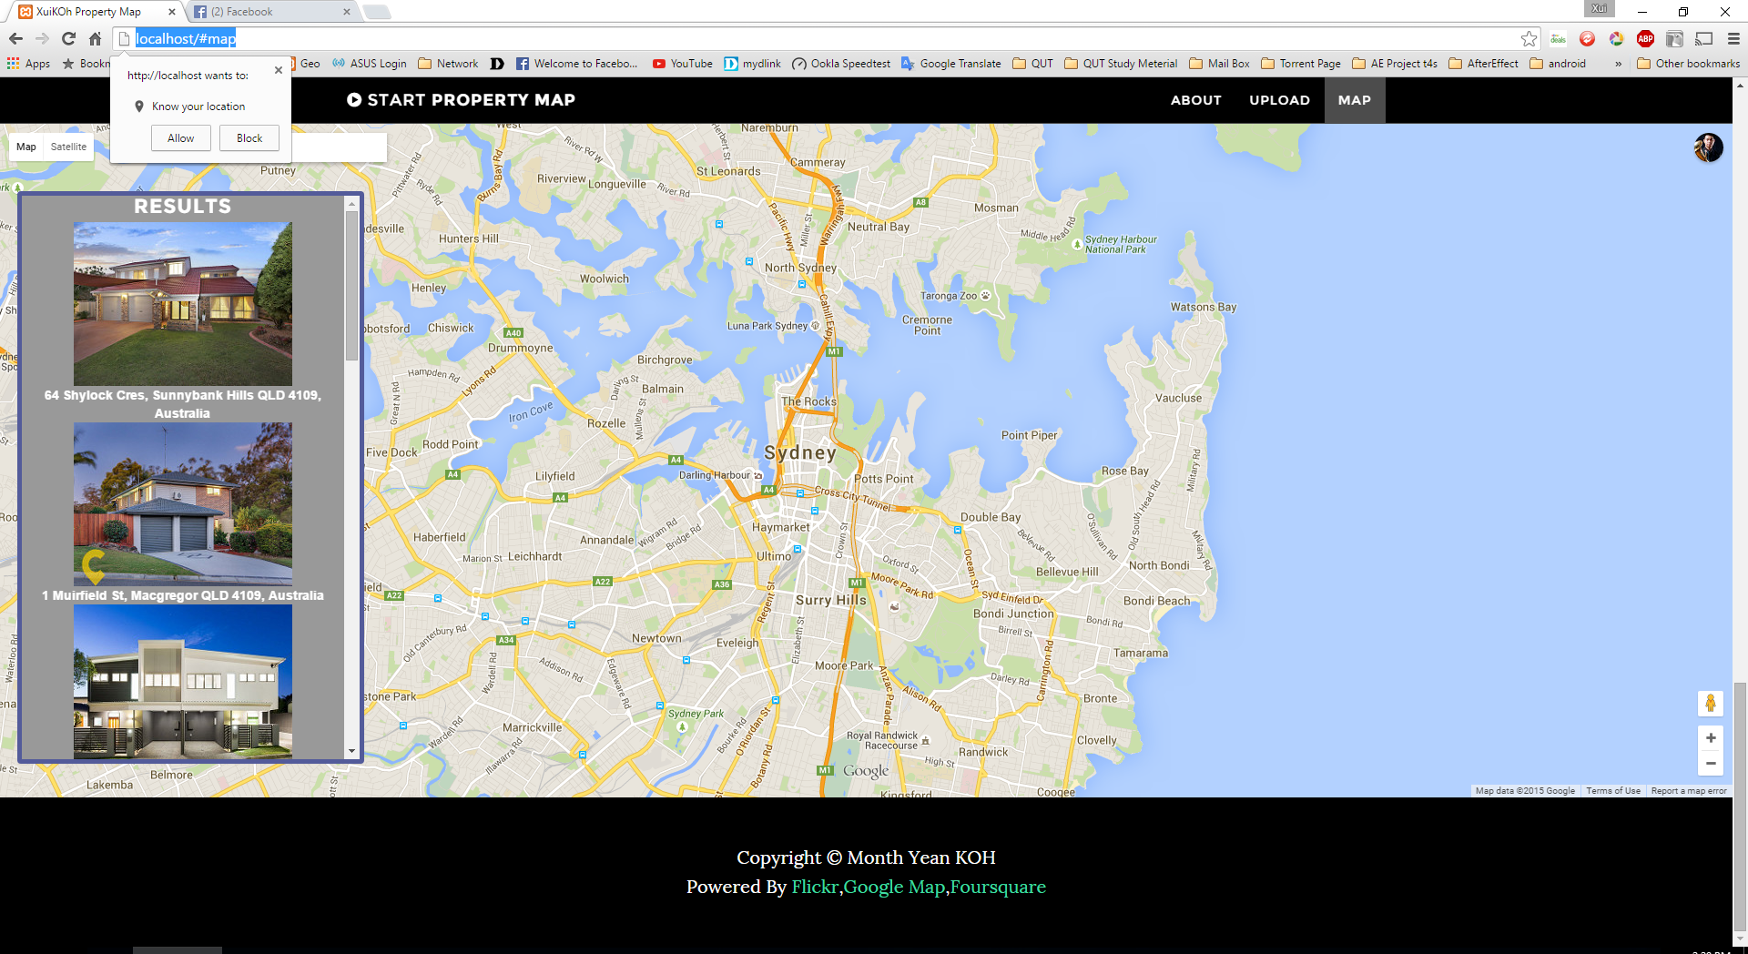

By Default your current location will be load once you allow the access to know you location. If you block the extension to know you location, you location will not be loaded and the map will not prompt to your current location. And the google map will remain the map on the screen that showing with Sydney map.

### Test 2 Undefined Search Location Input

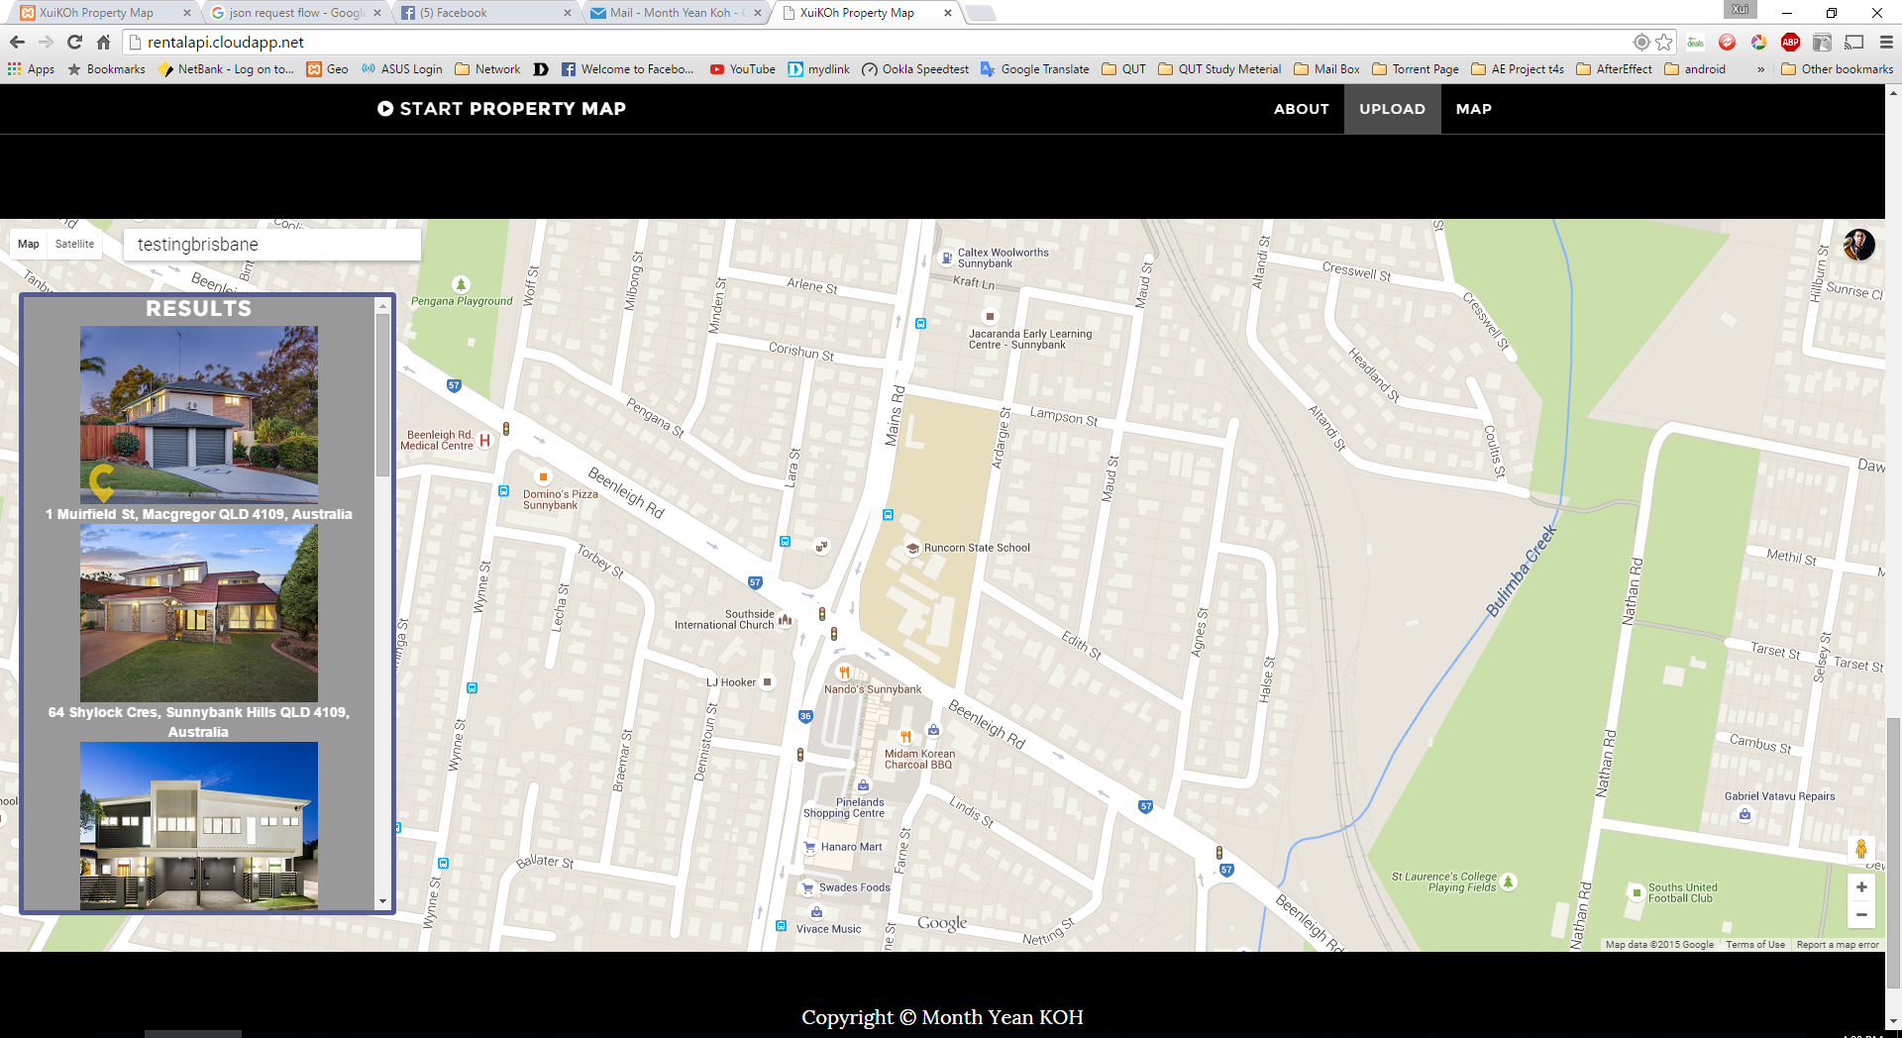

As the plan user can search the location manually and browsed around on that map area, by entering the location name on the search box that on the top left corner and the location place will be autocomplete by google auto complete API. Therefore the result location result will not prompt out if the user enter the searching keyword that have no matches with google map.

### Test 3 Different Combination Tags

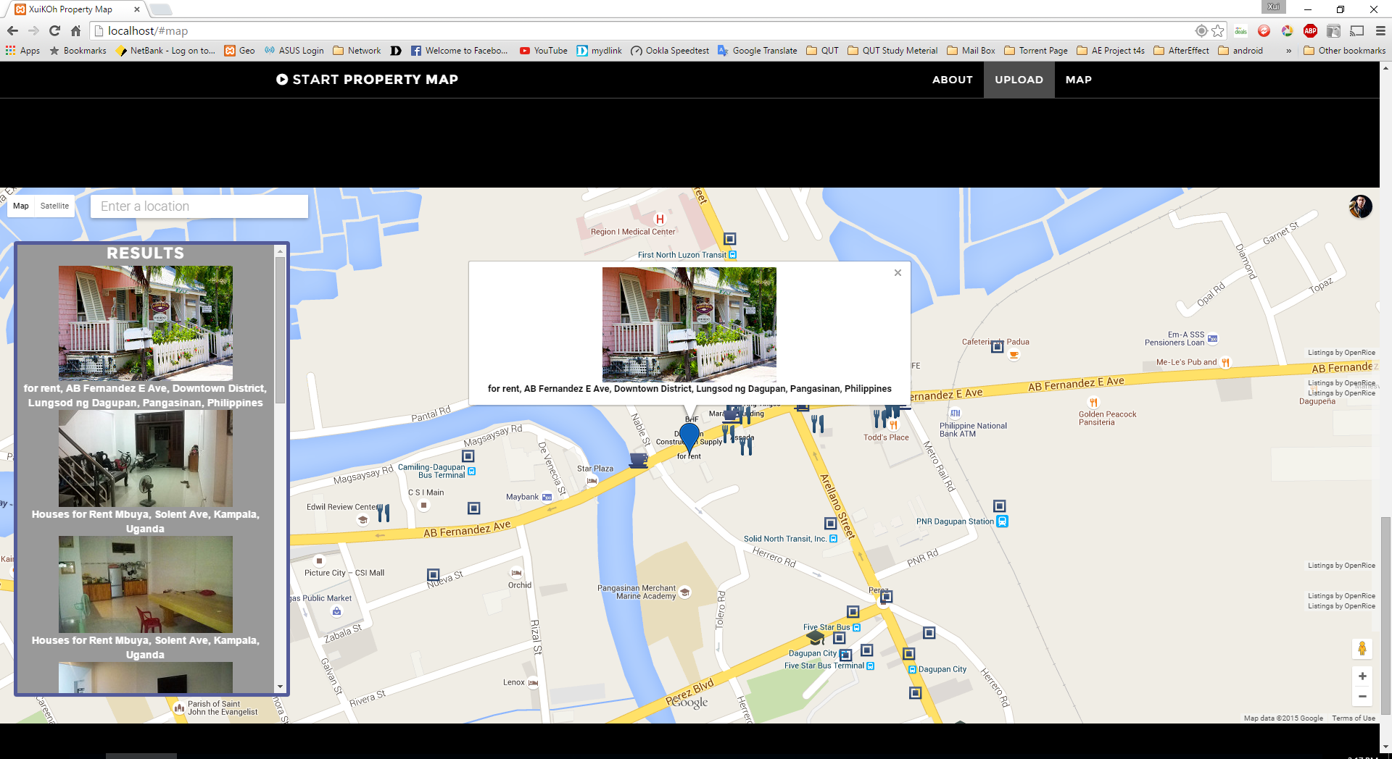

The Tags are predefine in the server and end user have no changes to change it and it force to use with the tags that have define in the server.

Although there are few only Result showed the matching Between Flickr Photo Tags and Come with Address with Photo Title. That by make used of the very common tag with “House & Rent” And there are 500 photo Flickr Photo data but there are only few Result on the Google Map With contain with the address as the photo title. And there is only 1 Result with the combination Tags with “House & For & Rent”

### Test 4 Preset Combination Tag

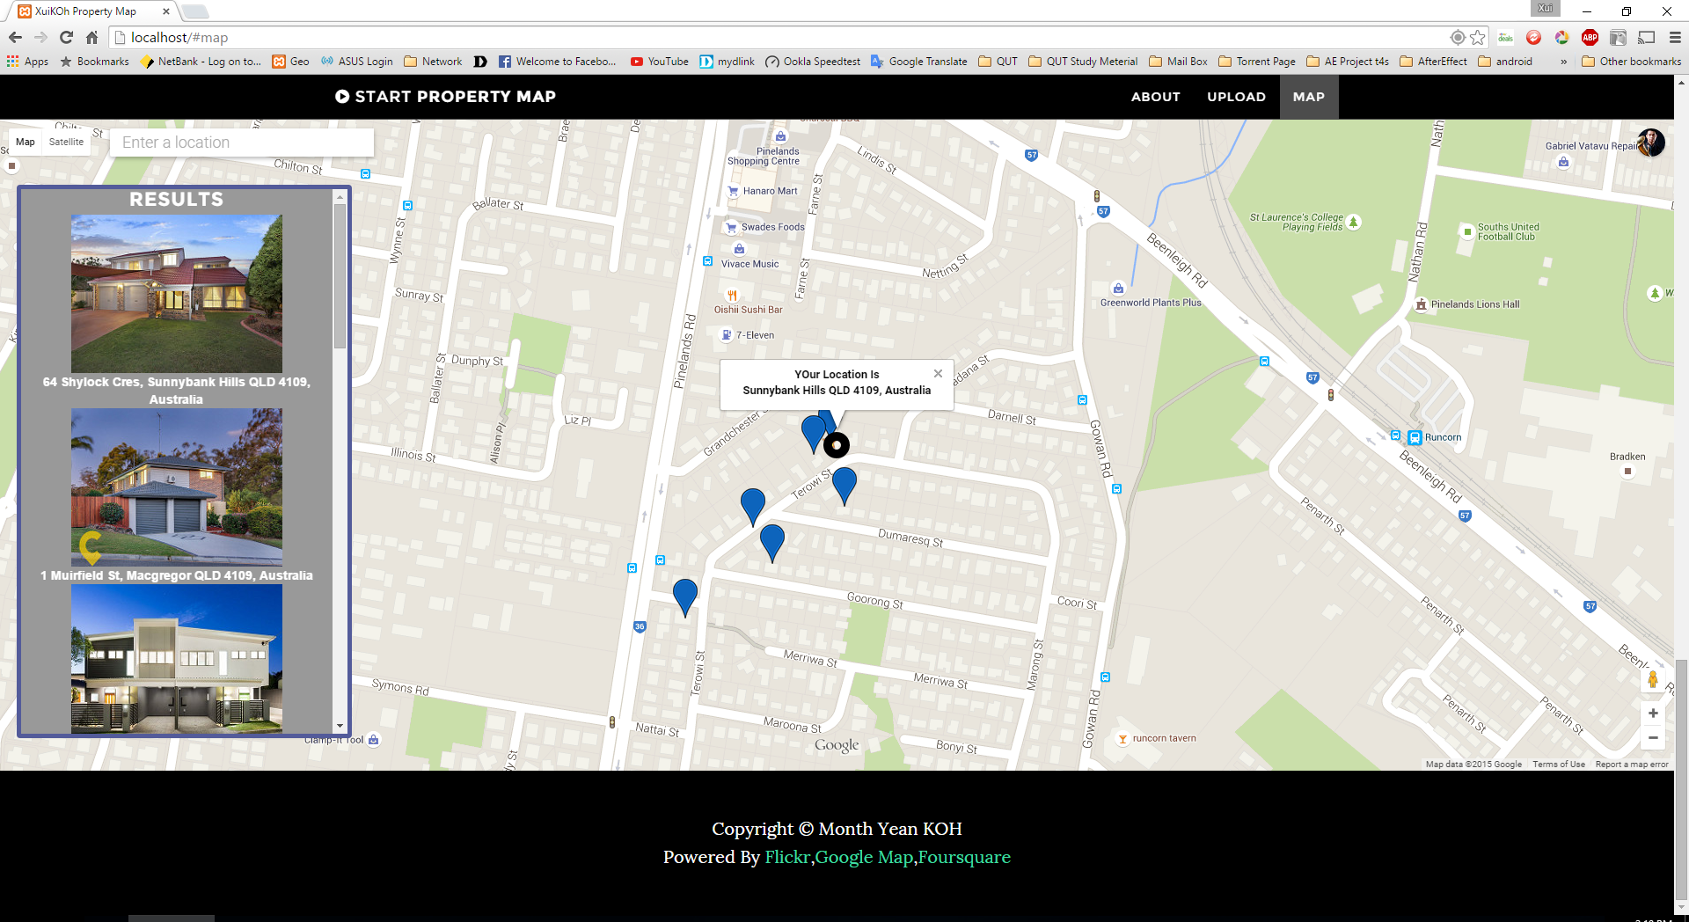

At last I was carrying out the test plan with preset the Flickr Photo Searching Tag searching Combination with “House & Rent & Brisbane” and I have upload some property photo to the Flickr database with Following According to the Tags and put The House Address As the Photo Title. And it work perfectly well. It Show Up all the Result That I expected.

### Test 5 Self Upload Photo To The Map

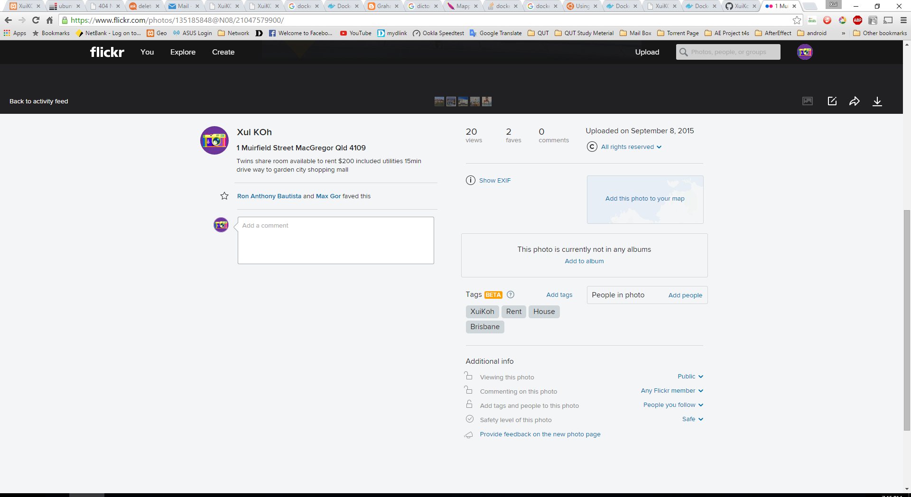

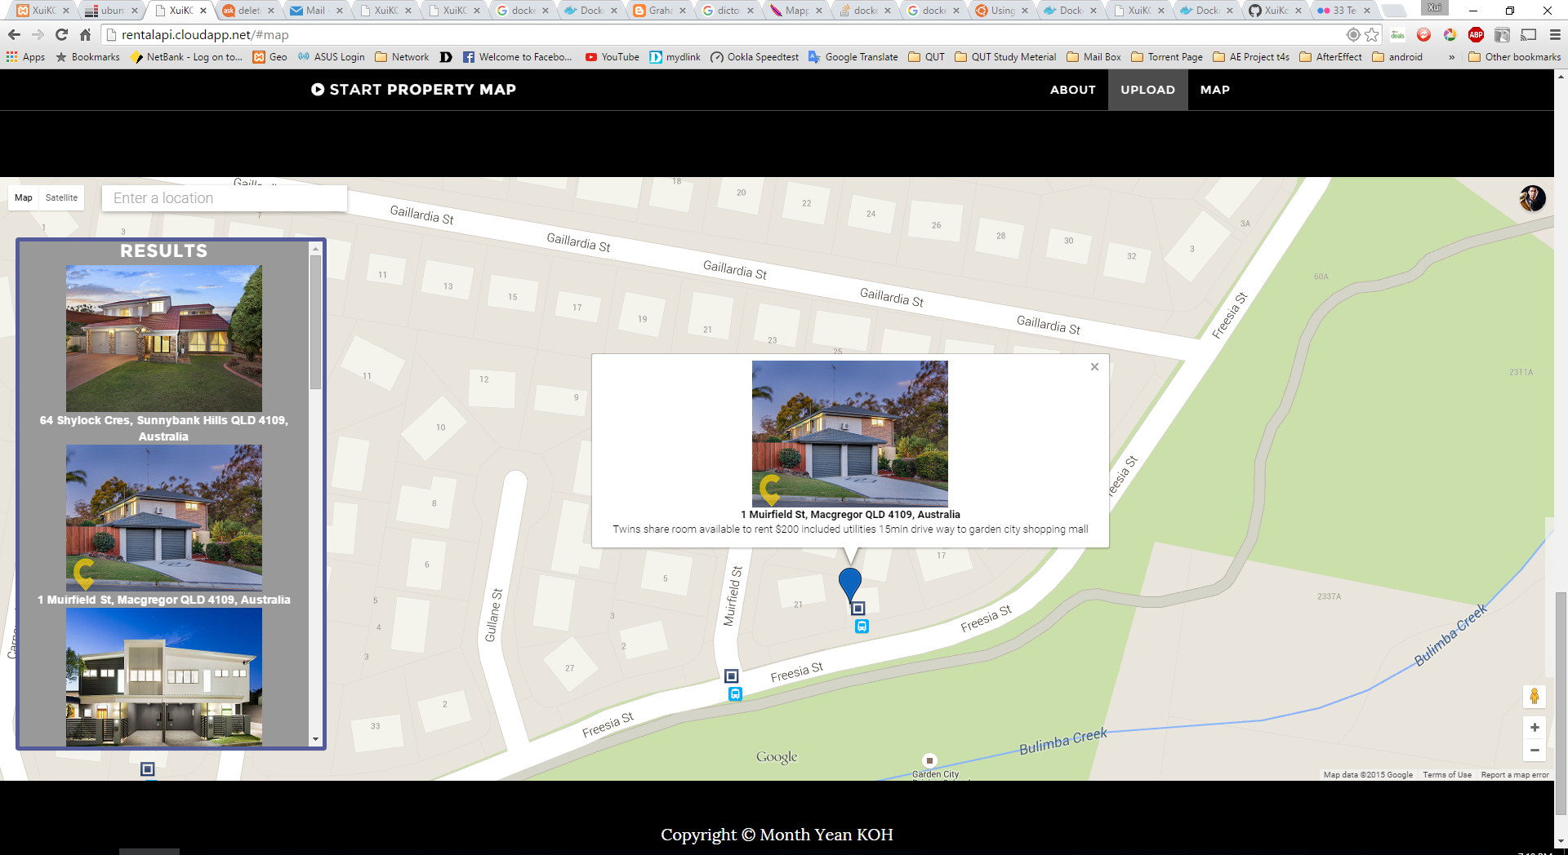

As I upload the Photo to Flickr Database and Specify the Title as the house address and specify the tags with Brisbane, House, and Rent. So few minutes later your photo might be showing in the map with the specify house location as the address that you stated photo Title.

Beside the Description of the photo will also come along with the photo and stated on the info window. The description will not show up if there is no description available.

### Test 6 Invalid Title Of The Photo as House Address

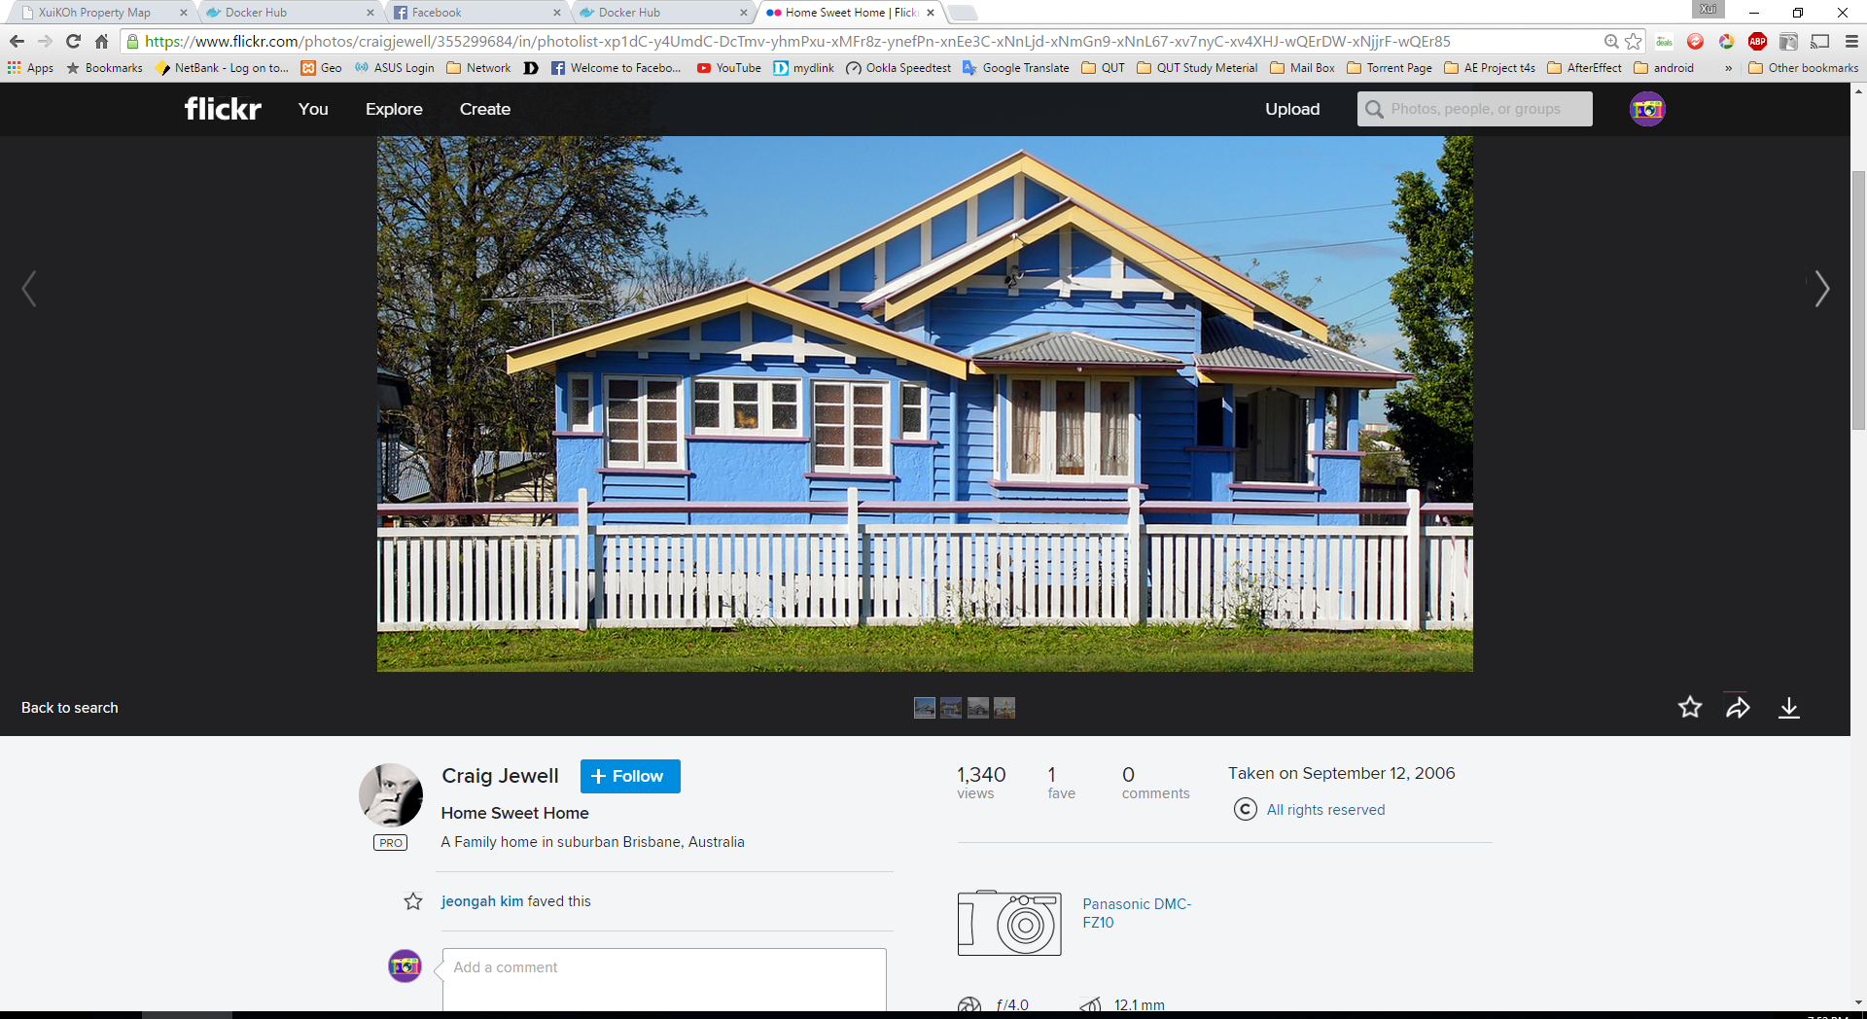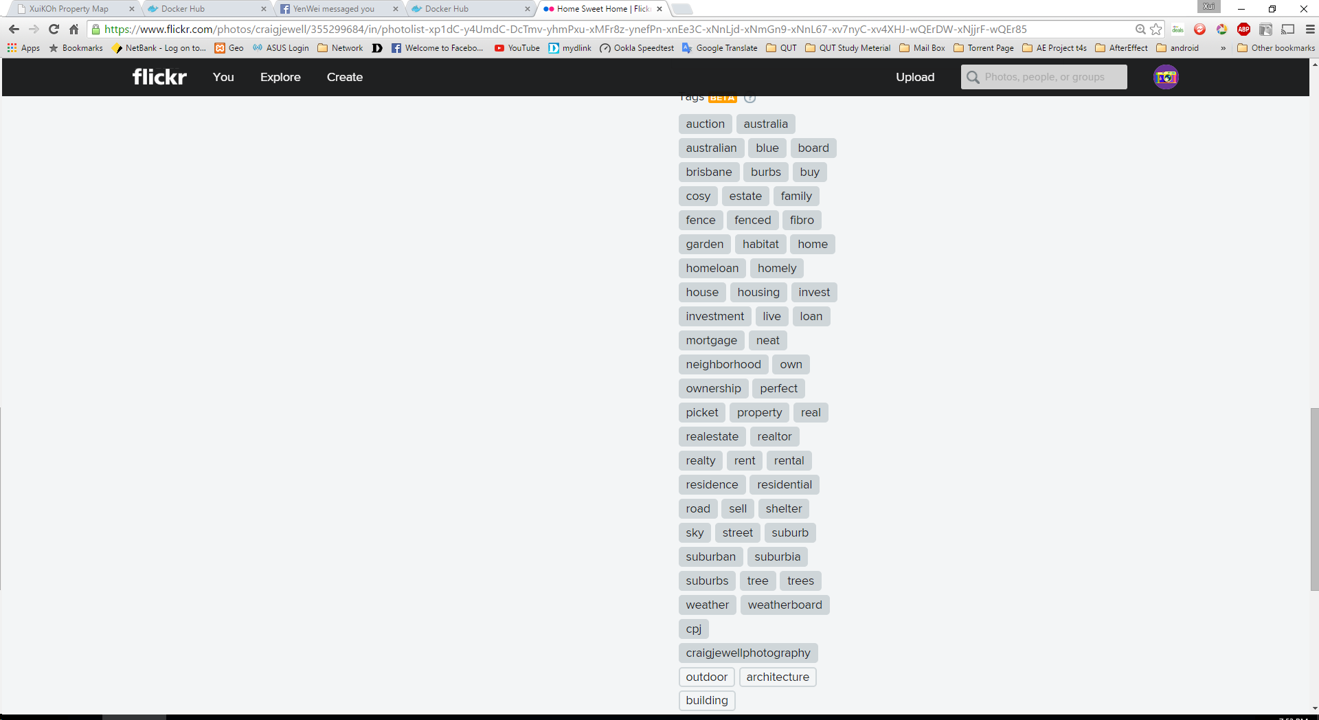

Beside the House Photo and Marker will not show up in the map if the photo that user has upload to the Flickr have no those 3 Combination of Tags with (Brisbane, House, Rent) and also the Photo title are not consider as a valid address. As the figure above for that user who upload a house photo who have the valid tags combination with (Brisbane House Rent). But it fail to have valid Photo Title that as house address. Therefore this house photo and marker will not showing up in the map.

## Limitation

Flickr API only allow maximum with 500 Result responding. So that I might skip out some place because it only result 500 Result in a time, somehow there are only few result in Google Map that matching the combination of Flickr Tags as well putting the house address as the Title of the Photo. Although there a lot of photo contain with that combination of tag.

Furthermore if the Photo Title without full house address, The result of the google map might be resulting the different place, area, region, country but with the same street name.

Beside Somehow there is also some irrelevant photo that not related of the house showing up, although pass through all the keyword and Tags matches. It unable to determine if there is not housing photo that by Flickr Database. Beside there also have some duplicated result or different information but come with the same house address. And the google map unable to decide which need take off. I might cause about confusing for end user.

Rather than that there is a Certain Amount of latency appeal when loading the Data from another API and somehow the data might not been showing up at all or somehow the data are showing up without in time, I found that this issue area depending either the internet Connection from the client side or from the server side somehow are also depends on the API. So that there might be having inaccurate information display on the google map info window when user first click for the marker. And might have to refresh the page while the result panel are not loading up.

# Possible Extension

I wish to extend the function for this web application if time possible, I would like to add some extra feature to the result panel as well as the Property Map. With the list are sync together when end user browse around on the map. And make it goes more perfect and I might able to perform well in the real living environment.

# Appendix

## User Guild

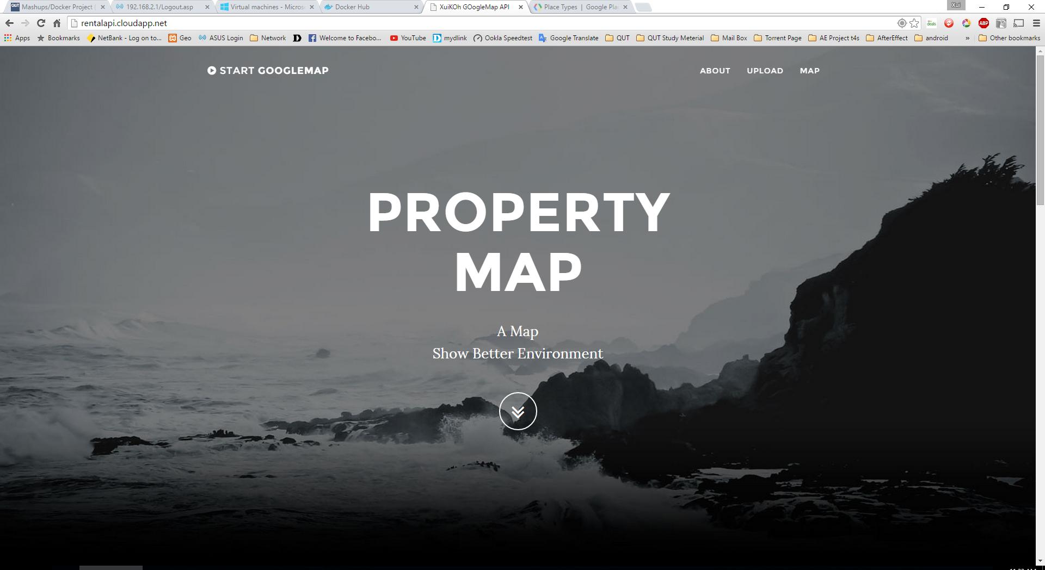

User able to access the website by <http://rentalapi.cloudapp.net/> by any of the device and platform as well as you enter the link of the web site to your device web browser and it will directly you to the Property Map Web Page and you are good to go to browse around the web page and play around on the web page. It can be click on the menu button that stated on the top of the side, will be navigate to certain section once click.

## DockerFile

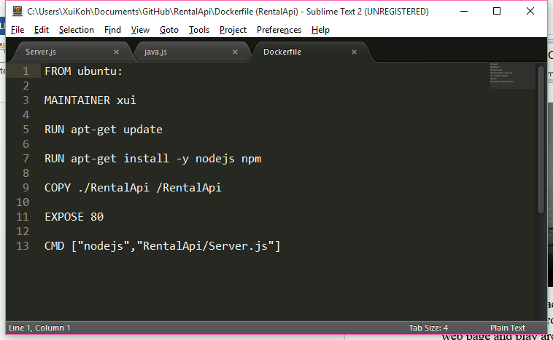

The Dockerfile Will made the image of Ubuntu and install nodejs into the Ubuntu OS and copy my web repository into the image and expose with port 80, and execute the command to start up the server at last